**Vizsgaremek**

KSH iT Zrt.

**Logical Topology concept:**

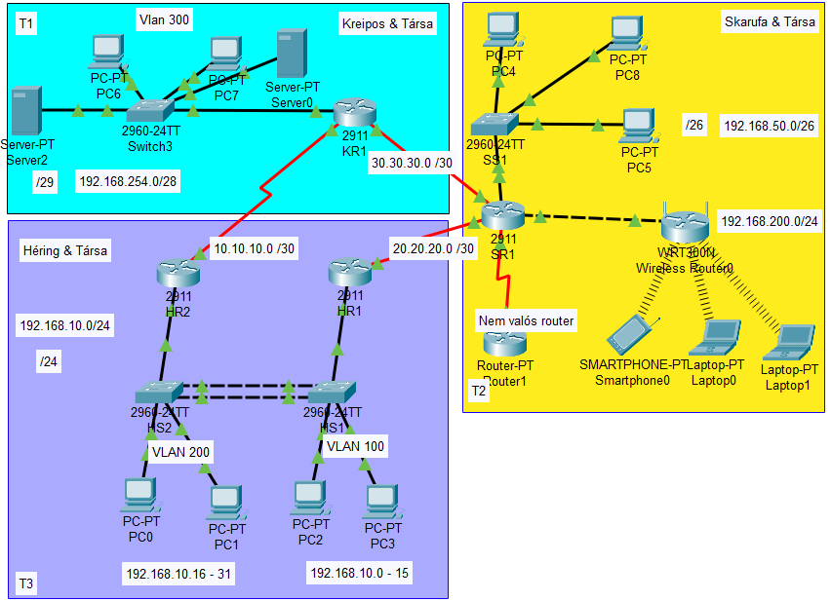

**Physical Topology concept:**

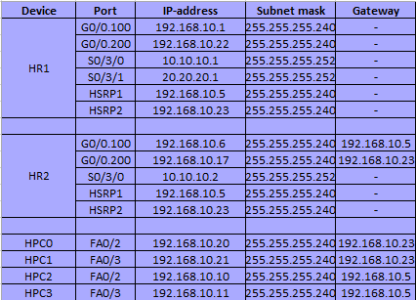**Ip-address table:**

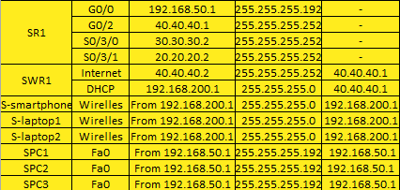

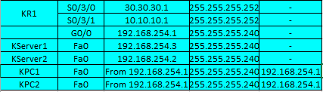

**VLAN table:**

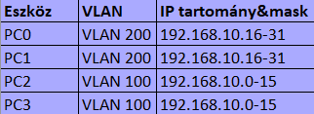

**Felosztások/leírás:**

Ezt a vizsgaremeket 3-an csináltuk.

**Tagok:**

**-**Héring Máté

-Skarufa Ákos

-Kreipos Gábor

Egy hálózati szolgáltató cég volt a gondolat menet. DE voltak fennakadások.

**Fennakadások (később megoldott):**

-Server konfigurálás

**Ping-ek/tesztelések:**

HSRP protokoll:

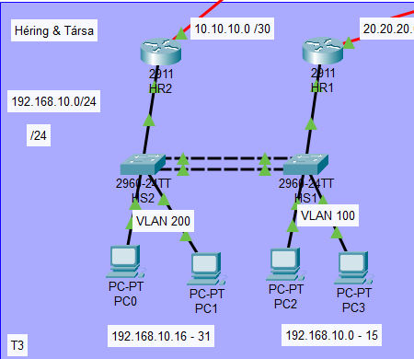

WiFi protokoll(csak bentről-kifele lehet pinggelni):

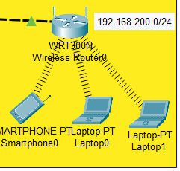

Linux/Windows Server kiépítése:

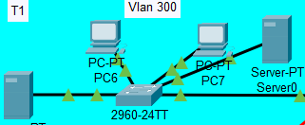

VLAN protokoll:

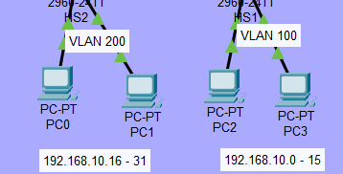

PC0→PC4

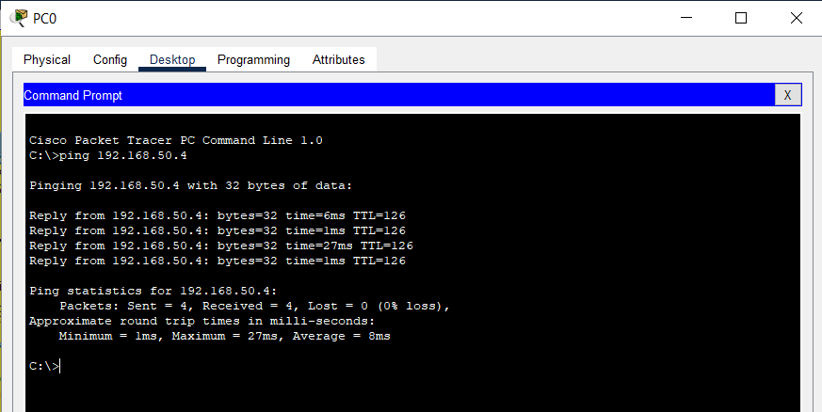

PC0→PC6

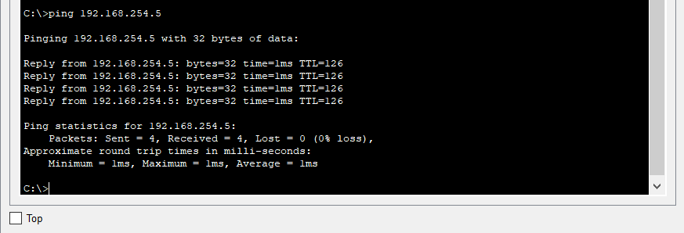

LAPTOP1→PC0

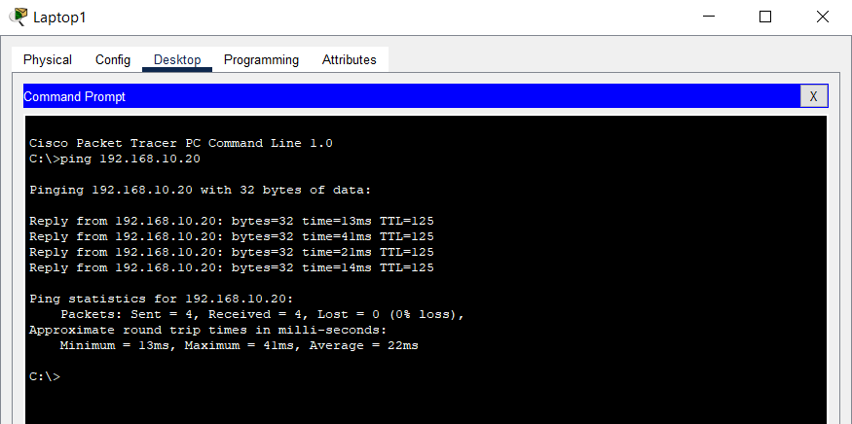

Héring és Társa

IPv4 HSRP működik a hálózatban(IPv6 Nem működhet Cisco – ban).

HR1:

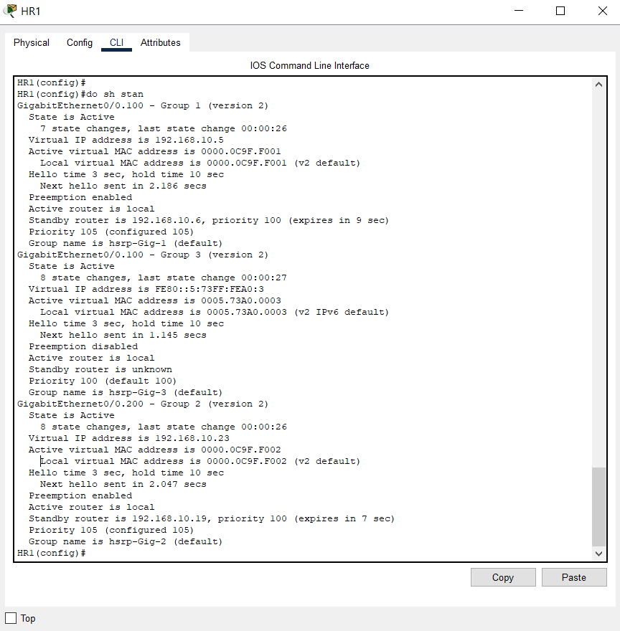

HR2:

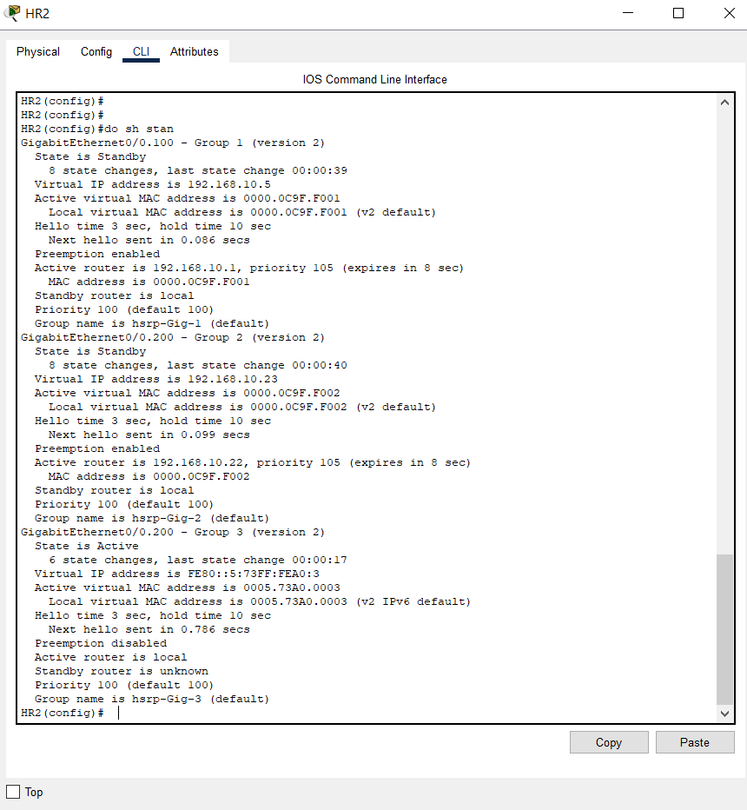

Etherchannel:

HS1: 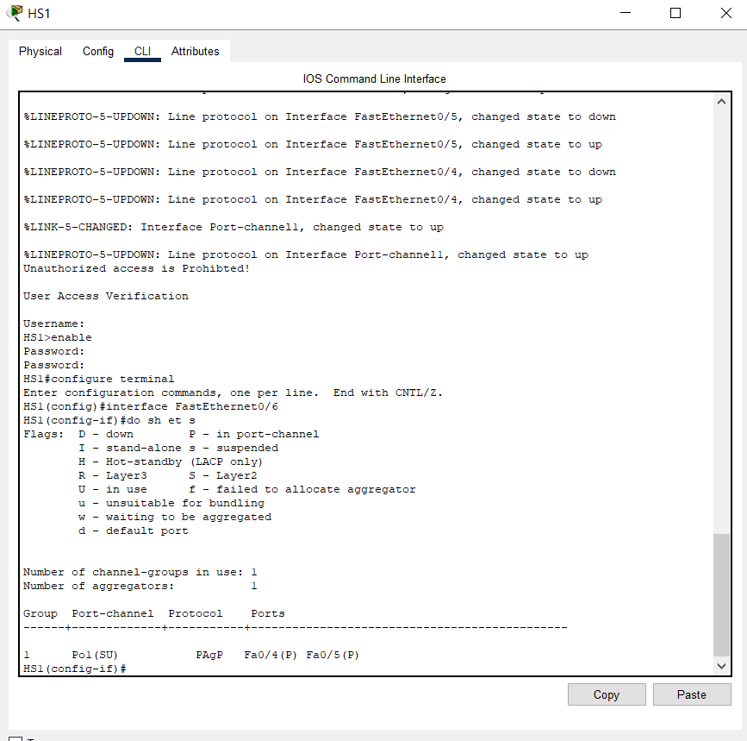

HS2: 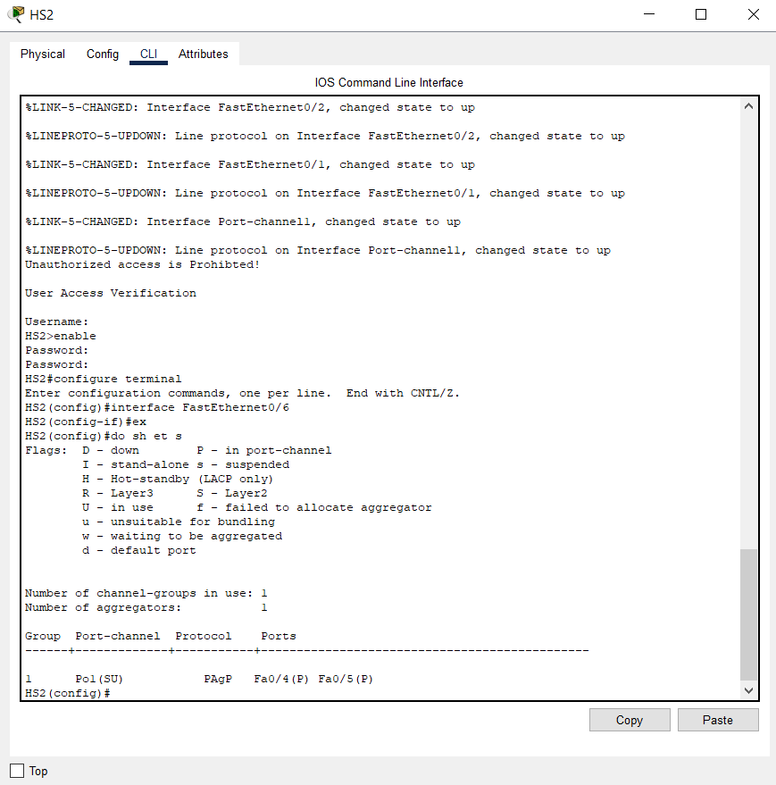

OSPF

HR1: 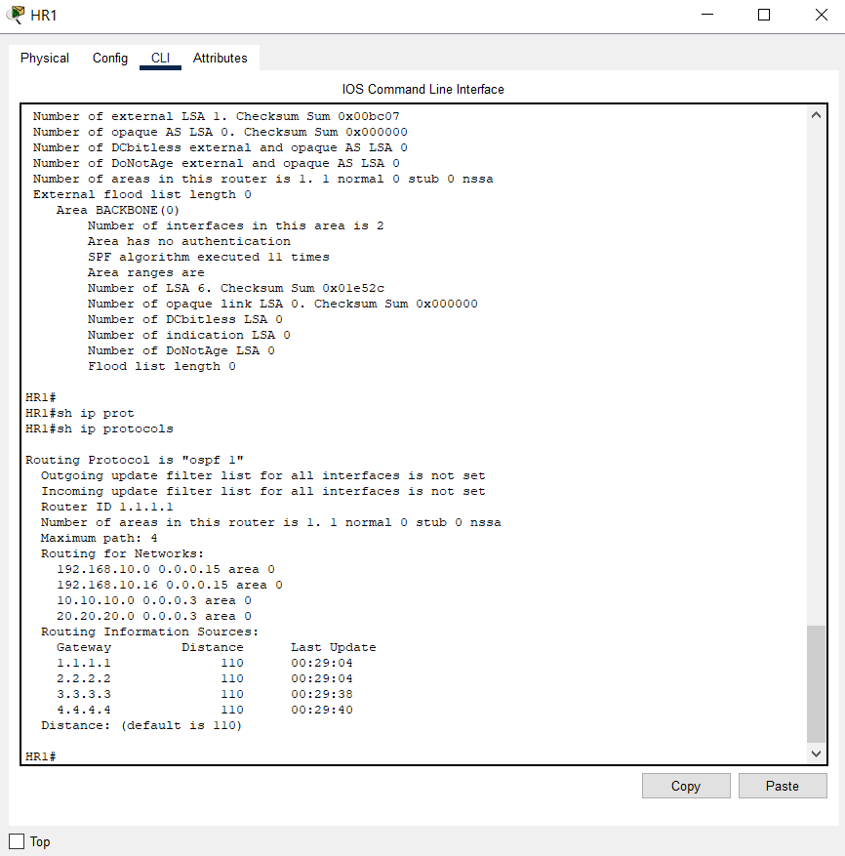

HR2:

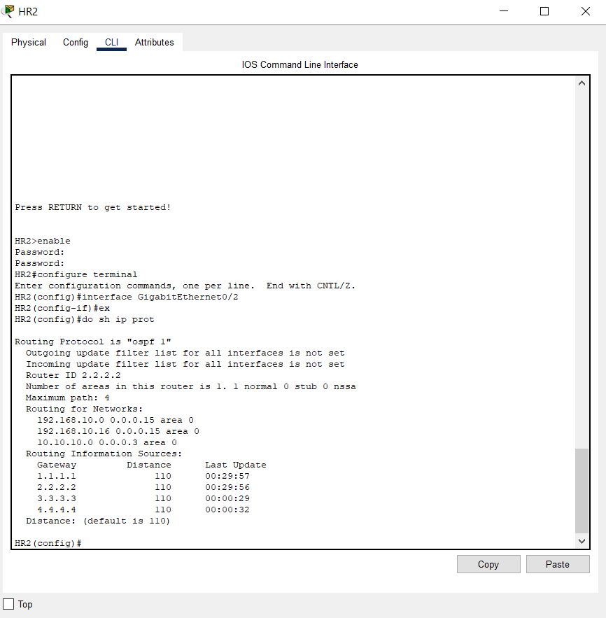

WAN kapcsolat HR1 és SR1 között:

HR1: 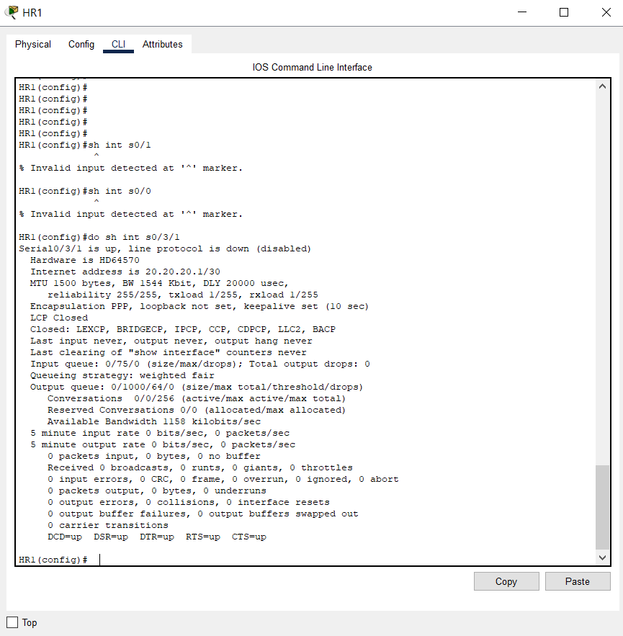

SR1: 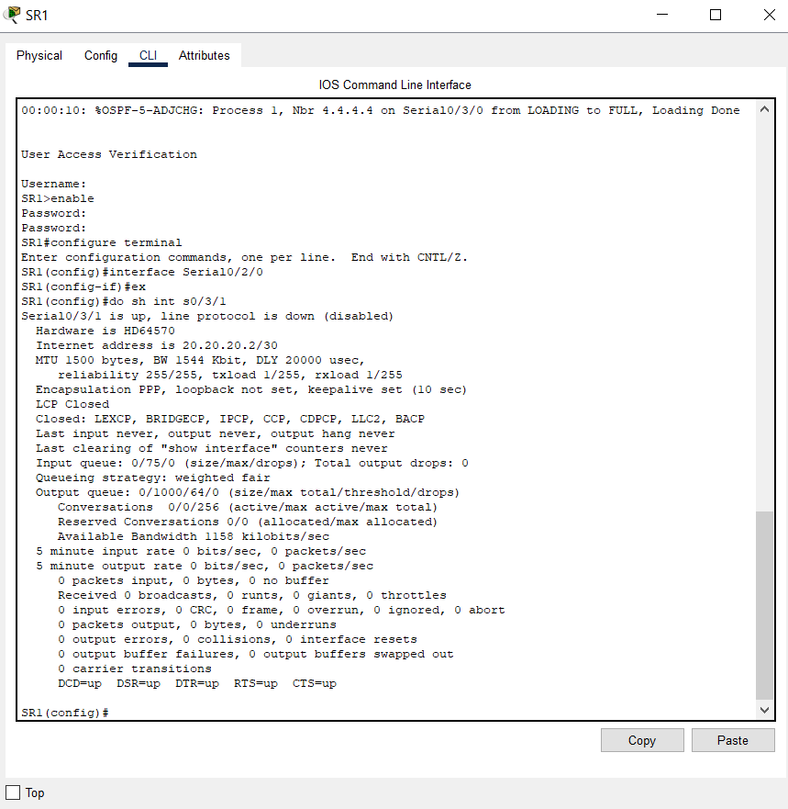

VLAN:

HS1: 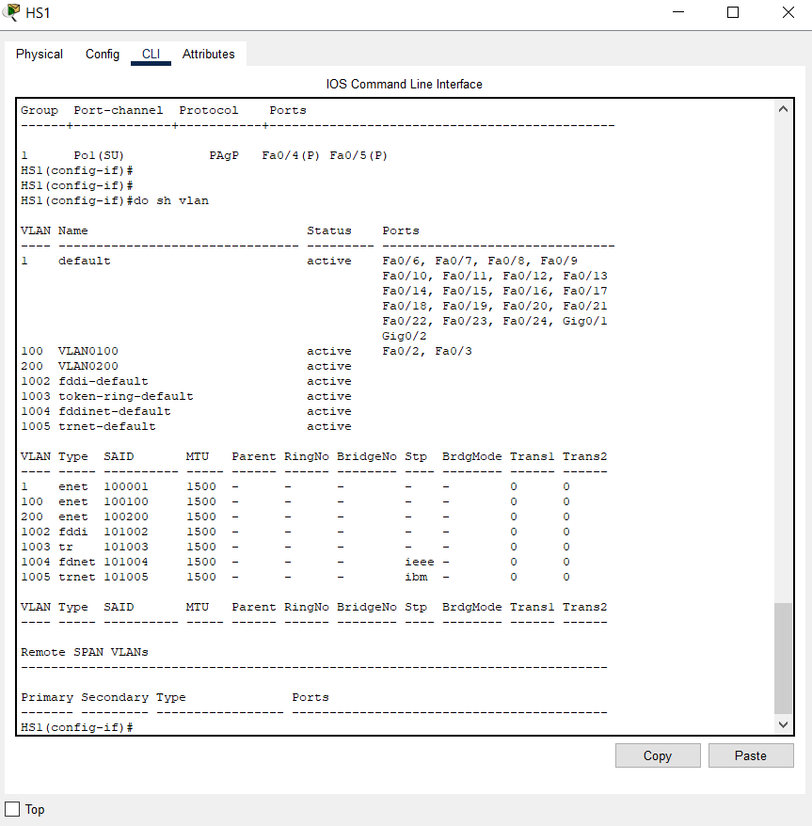

HS2: 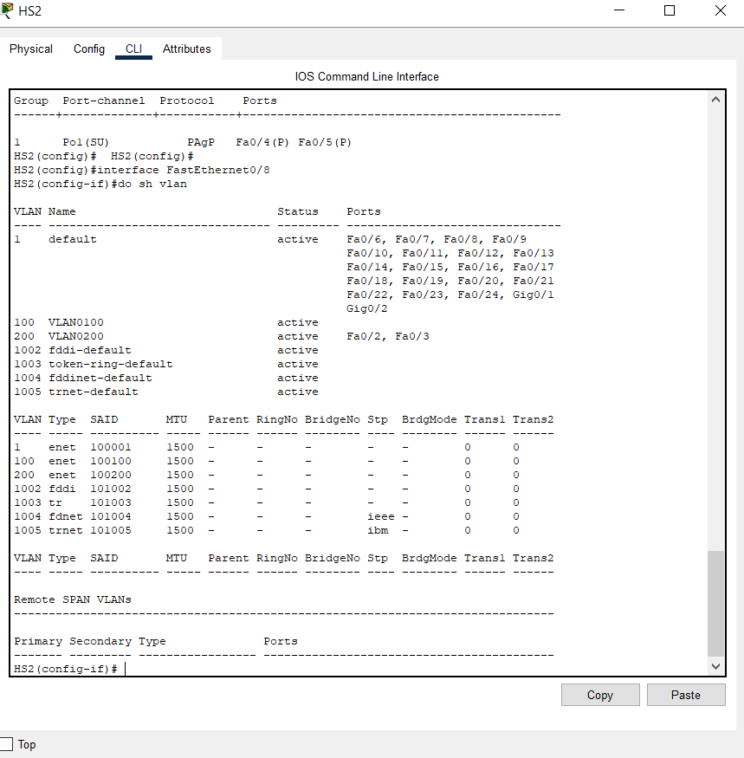

NAT

HR2:

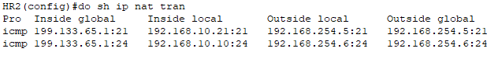

WAN

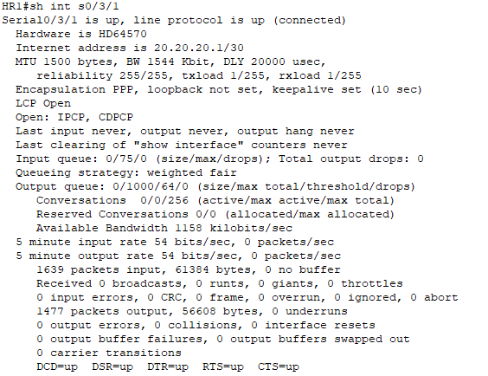

Run-Config:

HR1:

Building configuration...

Current configuration : 1989 bytes

!

version 15.1

no service timestamps log datetime msec

no service timestamps debug datetime msec

service password-encryption

!

hostname HR1

!

!

!

enable password 7 0822455D0A16

!

!

!

!

!

!

no ip cef

ipv6 unicast-routing

!

no ipv6 cef

!

!

!

username SR1 password 7 0822455D0A16

username admin password 7 0822455D0A16

!

!

license udi pid CISCO2911/K9 sn FTX15240ZEN-

!

!

!

!

!

!

!

!

!

ip domain-name kando.com

!

!

spanning-tree mode rapid-pvst

!

!

!

!

!

!

interface GigabitEthernet0/0

no ip address

duplex auto

speed auto

ipv6 enable

!

interface GigabitEthernet0/0.100

encapsulation dot1Q 100

ip address 192.168.10.1 255.255.255.240

ip nat inside

ipv6 address FE80::10 link-local

ipv6 address 2001:DB8:ACAD:10::1/64

ipv6 enable

standby version 2

standby 1 ip 192.168.10.5

standby 1 priority 105

standby 1 preempt

!

interface GigabitEthernet0/0.200

encapsulation dot1Q 200

ip address 192.168.10.22 255.255.255.240

ip nat inside

standby version 2

standby 2 ip 192.168.10.23

standby 2 priority 105

standby 2 preempt

!

interface GigabitEthernet0/1

no ip address

duplex auto

speed auto

!

interface GigabitEthernet0/2

no ip address

duplex auto

speed auto

!

interface Serial0/3/0

ip address 10.10.10.1 255.255.255.252

clock rate 2000000

!

interface Serial0/3/1

ip address 20.20.20.1 255.255.255.252

encapsulation ppp

ppp authentication chap

ip nat outside

clock rate 2000000

!

interface Vlan1

no ip address

shutdown

!

router ospf 1

router-id 1.1.1.1

log-adjacency-changes

network 192.168.10.0 0.0.0.15 area 0

network 192.168.10.16 0.0.0.15 area 0

network 10.10.10.0 0.0.0.3 area 0

network 20.20.20.0 0.0.0.3 area 0

default-information originate

!

ip nat pool NAT1 199.133.65.1 199.133.65.15 netmask 255.255.255.240

ip nat inside source list 1 pool NAT1 overload

ip classless

!

ip flow-export version 9

!

!

!

banner motd ^CUnauthorized access is Prohibted!^C

!

!

!

!

line con 0

login local

!

line aux 0

!

line vty 0 4

login

transport input ssh

!

!

!

end

HR2:

Building configuration...

Current configuration : 1868 bytes

!

version 15.1

no service timestamps log datetime msec

no service timestamps debug datetime msec

service password-encryption

!

hostname HR2

!

!

!

enable password 7 0822455D0A16

!

!

!

!

!

!

no ip cef

ipv6 unicast-routing

!

no ipv6 cef

!

!

!

username admin password 7 0822455D0A16

!

!

license udi pid CISCO2911/K9 sn FTX152448FQ-

!

!

!

!

!

!

!

!

!

ip domain-name kando.com

!

!

spanning-tree mode rapid-pvst

!

!

!

!

!

!

interface GigabitEthernet0/0

no ip address

duplex auto

speed auto

!

interface GigabitEthernet0/0.100

encapsulation dot1Q 100

ip address 192.168.10.6 255.255.255.240

ip nat inside

standby version 2

standby 1 ip 192.168.10.5

standby 1 priority 110

standby 1 preempt

!

interface GigabitEthernet0/0.200

encapsulation dot1Q 200

ip address 192.168.10.19 255.255.255.240

ip nat inside

ipv6 address FE80::10 link-local

ipv6 address 2001:DB8:ACAD:20::1/64

ipv6 enable

standby version 2

standby 2 ip 192.168.10.23

standby 2 priority 110

standby 2 preempt

!

interface GigabitEthernet0/1

no ip address

duplex auto

speed auto

!

interface GigabitEthernet0/2

no ip address

duplex auto

speed auto

standby version 2

!

interface Serial0/3/0

ip address 10.10.10.2 255.255.255.252

ip nat outside

clock rate 2000000

!

interface Serial0/3/1

no ip address

clock rate 2000000

!

interface Vlan1

no ip address

shutdown

!

router ospf 1

router-id 2.2.2.2

log-adjacency-changes

network 192.168.10.0 0.0.0.15 area 0

network 192.168.10.16 0.0.0.15 area 0

network 10.10.10.0 0.0.0.3 area 0

!

ip nat pool NAT1 199.133.65.1 199.133.65.15 netmask 255.255.255.240

ip nat inside source list 1 pool NAT1 overload

ip classless

!

ip flow-export version 9

!

!

access-list 1 permit 192.168.10.0 0.0.0.255

!

banner motd ^CUnauthorized access is Prohibted!^C

!

!

!

!

line con 0

login local

!

line aux 0

!

line vty 0 4

login

transport input ssh

!

!

!

end

HS1:

Building configuration...

Current configuration : 2616 bytes

!

version 15.0

no service timestamps log datetime msec

no service timestamps debug datetime msec

service password-encryption

!

hostname HS1

!

enable password 7 0822455D0A16

!

!

!

ip domain-name kando.com

!

username admin privilege 1 password 7 0822455D0A16

!

!

!

spanning-tree mode rapid-pvst

spanning-tree extend system-id

!

interface Port-channel1

!

interface FastEthernet0/1

switchport mode trunk

spanning-tree portfast

spanning-tree bpduguard enable

!

interface FastEthernet0/2

switchport access vlan 100

spanning-tree portfast

spanning-tree bpduguard enable

!

interface FastEthernet0/3

switchport access vlan 100

spanning-tree portfast

spanning-tree bpduguard enable

!

interface FastEthernet0/4

channel-group 1 mode desirable

spanning-tree portfast

spanning-tree bpduguard enable

!

interface FastEthernet0/5

channel-group 1 mode desirable

spanning-tree portfast

spanning-tree bpduguard enable

!

interface FastEthernet0/6

switchport access vlan 999

shutdown

!

interface FastEthernet0/7

switchport access vlan 999

shutdown

!

interface FastEthernet0/8

switchport access vlan 999

shutdown

!

interface FastEthernet0/9

switchport access vlan 999

shutdown

!

interface FastEthernet0/10

switchport access vlan 999

shutdown

!

interface FastEthernet0/11

switchport access vlan 999

shutdown

!

interface FastEthernet0/12

switchport access vlan 999

shutdown

!

interface FastEthernet0/13

switchport access vlan 999

shutdown

!

interface FastEthernet0/14

switchport access vlan 999

shutdown

!

interface FastEthernet0/15

switchport access vlan 999

shutdown

!

interface FastEthernet0/16

switchport access vlan 999

shutdown

!

interface FastEthernet0/17

switchport access vlan 999

shutdown

!

interface FastEthernet0/18

switchport access vlan 999

shutdown

!

interface FastEthernet0/19

switchport access vlan 999

shutdown

!

interface FastEthernet0/20

switchport access vlan 999

shutdown

!

interface FastEthernet0/21

switchport access vlan 999

shutdown

!

interface FastEthernet0/22

switchport access vlan 999

shutdown

!

interface FastEthernet0/23

switchport access vlan 999

shutdown

!

interface FastEthernet0/24

switchport access vlan 999

shutdown

!

interface GigabitEthernet0/1

switchport access vlan 999

shutdown

!

interface GigabitEthernet0/2

switchport access vlan 999

shutdown

!

interface Vlan1

no ip address

shutdown

!

interface Vlan100

ip address 192.168.10.2 255.255.255.240

!

interface Vlan200

no ip address

!

banner motd ^CUnauthorized access is Prohibted!^C

!

!

!

line con 0

login local

!

line vty 0 4

login

transport input ssh

line vty 5 15

login

!

!

!

!

end

HS2:

Building configuration...

Current configuration : 2700 bytes

!

version 15.0

no service timestamps log datetime msec

no service timestamps debug datetime msec

service password-encryption

!

hostname HS2

!

enable password 7 0822455D0A16

!

!

!

ip domain-name kando.com

!

username admin privilege 1 password 7 0822455D0A16

!

!

!

spanning-tree mode rapid-pvst

spanning-tree extend system-id

!

interface Port-channel1

switchport mode trunk

!

interface FastEthernet0/1

switchport mode trunk

spanning-tree portfast

spanning-tree bpduguard enable

!

interface FastEthernet0/2

switchport access vlan 200

spanning-tree portfast

spanning-tree bpduguard enable

!

interface FastEthernet0/3

switchport access vlan 200

spanning-tree portfast

spanning-tree bpduguard enable

!

interface FastEthernet0/4

switchport mode trunk

channel-group 1 mode auto

spanning-tree portfast

spanning-tree bpduguard enable

!

interface FastEthernet0/5

switchport mode trunk

channel-group 1 mode auto

spanning-tree portfast

spanning-tree bpduguard enable

!

interface FastEthernet0/6

switchport access vlan 999

shutdown

!

interface FastEthernet0/7

switchport access vlan 999

shutdown

!

interface FastEthernet0/8

switchport access vlan 999

shutdown

!

interface FastEthernet0/9

switchport access vlan 999

shutdown

!

interface FastEthernet0/10

switchport access vlan 999

shutdown

!

interface FastEthernet0/11

switchport access vlan 999

shutdown

!

interface FastEthernet0/12

switchport access vlan 999

shutdown

!

interface FastEthernet0/13

switchport access vlan 999

shutdown

!

interface FastEthernet0/14

switchport access vlan 999

shutdown

!

interface FastEthernet0/15

switchport access vlan 999

shutdown

!

interface FastEthernet0/16

switchport access vlan 999

shutdown

!

interface FastEthernet0/17

switchport access vlan 999

shutdown

!

interface FastEthernet0/18

switchport access vlan 999

shutdown

!

interface FastEthernet0/19

switchport access vlan 999

shutdown

!

interface FastEthernet0/20

switchport access vlan 999

shutdown

!

interface FastEthernet0/21

switchport access vlan 999

shutdown

!

interface FastEthernet0/22

switchport access vlan 999

shutdown

!

interface FastEthernet0/23

switchport access vlan 999

shutdown

!

interface FastEthernet0/24

switchport access vlan 999

switchport mode access

shutdown

!

interface GigabitEthernet0/1

switchport access vlan 999

shutdown

!

interface GigabitEthernet0/2

switchport access vlan 999

shutdown

!

interface Vlan1

no ip address

shutdown

!

interface Vlan100

no ip address

!

interface Vlan200

ip address 192.168.10.18 255.255.255.240

!

banner motd ^CUnauthorized access is Prohibted!^C

!

!

!

line con 0

login local

!

line vty 0 4

login

transport input ssh

line vty 5 15

login

!

!

!

!

end

**Kreipos és Társa**

Static NAT:

KR1: 

OSPF: 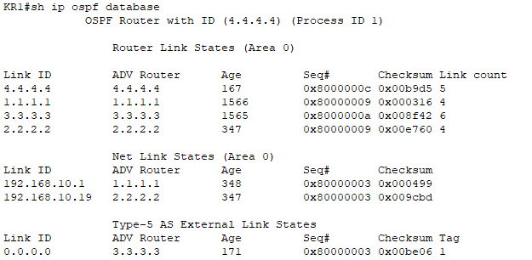

**KR1:**

Building configuration...

Current configuration : 1350 bytes

!

version 15.1

no service timestamps log datetime msec

no service timestamps debug datetime msec

no service password-encryption

!

hostname KR1

!

!

!

enable password cisco

!

!

!

!

!

!

no ip cef

no ipv6 cef

!

!

!

username admin password 0 cisco

!

!

license udi pid CISCO2911/K9 sn FTX1524Z777-

!

!

!

!

!

!

!

!

!

ip domain-name kando.com

!

!

spanning-tree mode pvst

!

!

!

!

!

!

interface GigabitEthernet0/0

ip address 192.168.254.1 255.255.255.240

ip nat inside

duplex auto

speed auto

!

interface GigabitEthernet0/1

no ip address

duplex auto

speed auto

!

interface GigabitEthernet0/2

no ip address

duplex auto

speed auto

!

interface Serial0/3/0

ip address 30.30.30.1 255.255.255.252

ip nat outside

clock rate 2000000

!

interface Serial0/3/1

ip address 10.10.10.1 255.255.255.252

ip nat outside

!

interface Vlan1

no ip address

shutdown

!

router ospf 1

router-id 4.4.4.4

log-adjacency-changes

network 192.168.254.0 0.0.0.15 area 0

network 10.10.10.0 0.0.0.3 area 0

network 30.30.30.0 0.0.0.3 area 0

default-information originate

!

ip nat inside source static 192.168.254.7 188.77.66.1

ip classless

ip route 199.133.65.1 255.255.255.255 10.10.10.2

!

ip flow-export version 9

!

!

access-list 1 permit 192.168.254.0 0.0.0.255

!

!

!

!

!

line con 0

login local

!

line aux 0

!

line vty 0 4

login local

transport input ssh

!

!

!

end

**KS1: !**

version 15.0

no service timestamps log datetime msec

no service timestamps debug datetime msec

no service password-encryption

!

hostname S3

!

enable password cisco

!

!

!

ip domain-name kando.com

!

username admin privilege 1 password 0 cisco

!

!

!

spanning-tree mode pvst

spanning-tree extend system-id

!

interface FastEthernet0/1

spanning-tree portfast

spanning-tree bpduguard enable

!

interface FastEthernet0/2

spanning-tree portfast

spanning-tree bpduguard enable

!

interface FastEthernet0/3

spanning-tree portfast

spanning-tree bpduguard enable

!

interface FastEthernet0/4

switchport access vlan 999

shutdown

!

interface FastEthernet0/5

switchport access vlan 999

shutdown

!

interface FastEthernet0/6

switchport access vlan 999

shutdown

!

interface FastEthernet0/7

switchport access vlan 999

shutdown

!

interface FastEthernet0/8

switchport access vlan 999

shutdown

!

interface FastEthernet0/9

switchport access vlan 999

shutdown

!

interface FastEthernet0/10

switchport access vlan 999

shutdown

!

interface FastEthernet0/11

switchport access vlan 999

shutdown

!

interface FastEthernet0/12

switchport access vlan 999

shutdown

!

interface FastEthernet0/13

switchport access vlan 999

shutdown

!

interface FastEthernet0/14

switchport access vlan 999

shutdown

!

interface FastEthernet0/15

switchport access vlan 999

shutdown

!

interface FastEthernet0/16

switchport access vlan 999

shutdown

!

interface FastEthernet0/17

switchport access vlan 999

shutdown

!

interface FastEthernet0/18

switchport access vlan 999

shutdown

!

interface FastEthernet0/19

switchport access vlan 999

shutdown

!

interface FastEthernet0/20

switchport access vlan 999

shutdown

!

interface FastEthernet0/21

switchport access vlan 999

shutdown

!

interface FastEthernet0/22

switchport access vlan 999

shutdown

!

interface FastEthernet0/23

spanning-tree portfast

spanning-tree bpduguard enable

!

interface FastEthernet0/24

spanning-tree portfast

spanning-tree bpduguard enable

!

interface GigabitEthernet0/1

switchport access vlan 999

shutdown

!

interface GigabitEthernet0/2

switchport access vlan 999

shutdown

!

interface Vlan1

no ip address

shutdown

!

interface Vlan300

ip address 192.168.254.3 255.255.255.240

!

!

!

!

line con 0

login local

!

line vty 0 4

login local

transport input ssh

line vty 5 15

login

!

!

!

!

end

**Skarufa & társai**

**Tesztelések:**

**DHCP teszt**

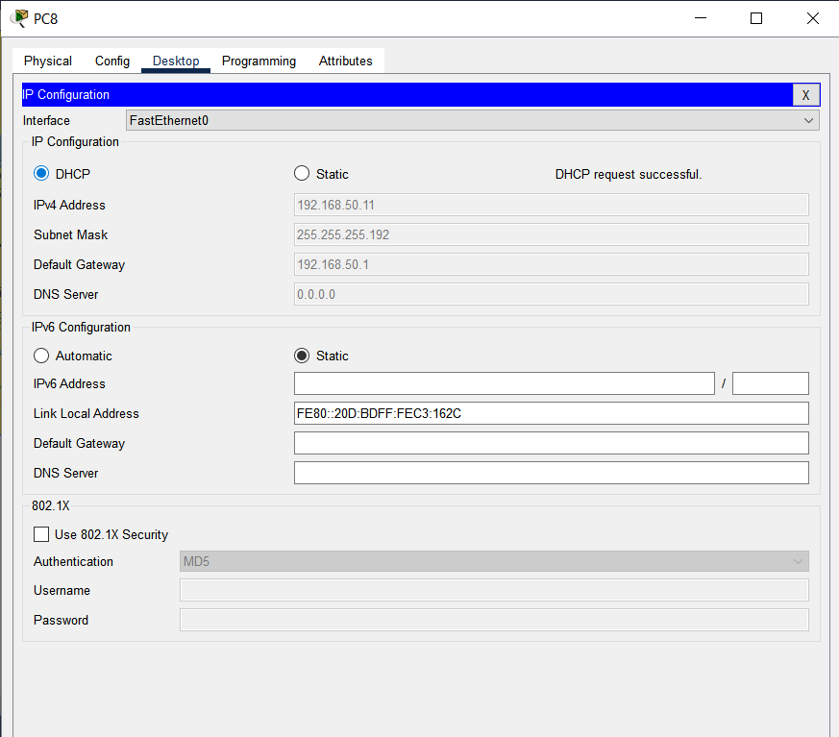

**WiFi csatlakozás:**

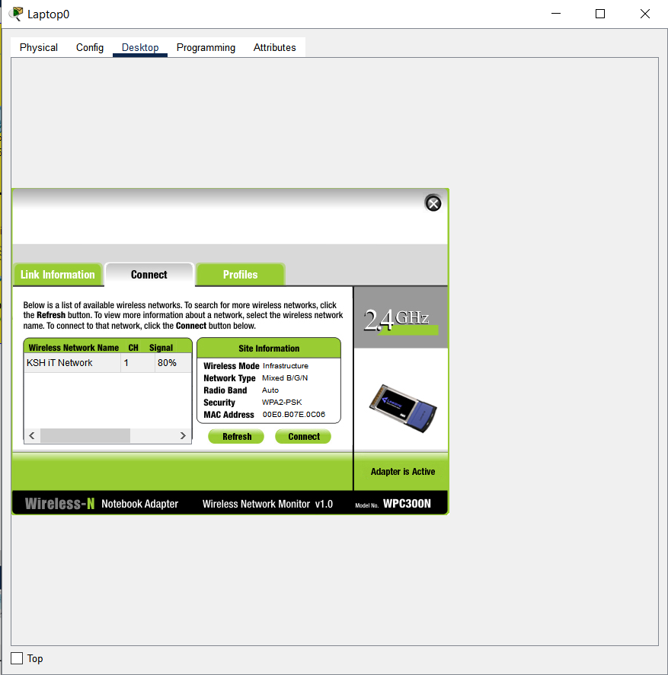

WAN

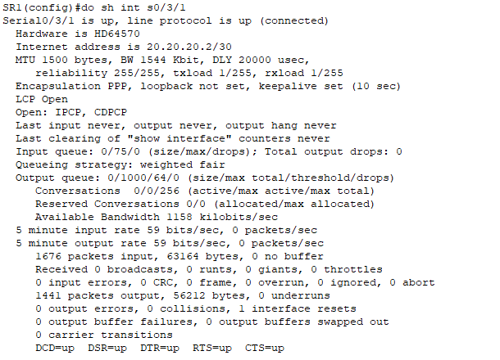

Run-Config:

SR1:

Building configuration...

Current configuration : 2022 bytes

!

version 15.1

no service timestamps log datetime msec

no service timestamps debug datetime msec

no service password-encryption

!

hostname SR1

!

!

!

enable password cisco

!

!

ip dhcp excluded-address 192.168.50.1 192.168.50.10

!

ip dhcp pool 1

network 192.168.50.0 255.255.255.192

default-router 192.168.50.1

!

!

!

no ip cef

no ipv6 cef

!

!

!

username HR1 password 0 cisco

username admin password 0 cisco

!

!

license udi pid CISCO2911/K9 sn FTX152454R4-

!

!

!

!

!

!

!

!

!

ip domain-name kando.com

!

!

spanning-tree mode pvst

!

!

!

!

!

!

interface GigabitEthernet0/0

ip address 192.168.50.1 255.255.255.192

ip access-group 100 in

duplex auto

speed auto

!

interface GigabitEthernet0/1

no ip address

duplex auto

speed auto

!

interface GigabitEthernet0/2

ip address 40.40.40.1 255.255.255.252

duplex auto

speed auto

!

interface Serial0/2/0

ip address 50.50.50.2 255.255.255.252

clock rate 2000000

!

interface Serial0/2/1

no ip address

clock rate 2000000

!

interface Serial0/3/0

ip address 30.30.30.2 255.255.255.252

!

interface Serial0/3/1

ip address 20.20.20.2 255.255.255.252

encapsulation ppp

ppp authentication chap

!

interface Vlan1

no ip address

shutdown

!

router ospf 1

router-id 3.3.3.3

log-adjacency-changes

network 20.20.20.0 0.0.0.3 area 0

network 30.30.30.0 0.0.0.3 area 0

network 40.40.40.0 0.0.0.3 area 0

network 10.10.10.0 0.0.0.63 area 0

network 192.168.200.0 0.0.0.255 area 0

network 192.168.50.0 0.0.0.63 area 0

default-information originate

!

router rip

!

ip classless

ip route 0.0.0.0 0.0.0.0 50.50.50.1

ip route 188.77.66.1 255.255.255.255 30.30.30.1

ip route 199.133.65.1 255.255.255.255 20.20.20.1

ip route 192.133.65.1 255.255.255.255 20.20.20.1

!

ip flow-export version 9

!

!

access-list 1 permit host 192.168.10.10

access-list 100 deny tcp 192.168.50.0 0.0.0.255 host 192.168.254.2 eq www

access-list 100 permit ip any any

!

!

!

!

!

line con 0

password cisco

login local

!

line aux 0

!

line vty 0 4

access-class 1 in

login local

transport input ssh

!

!

!

end

SS1:

Current configuration : 2442 bytes

!

version 15.0

no service timestamps log datetime msec

no service timestamps debug datetime msec

no service password-encryption

!

hostname SS1

!

enable password cisco

!

!

!

ip domain-name kando.com

!

username admin privilege 1 password 0 cisco

!

!

!

spanning-tree mode pvst

SS1(config)#do sh run

Building configuration...

Current configuration : 2442 bytes

!

version 15.0

no service timestamps log datetime msec

no service timestamps debug datetime msec

no service password-encryption

!

hostname SS1

!

enable password cisco

!

!

!

ip domain-name kando.com

!

username admin privilege 1 password 0 cisco

!

!

!

spanning-tree mode pvst

spanning-tree extend system-id

!

interface FastEthernet0/1

switchport mode access

spanning-tree portfast

spanning-tree bpduguard enable

!

interface FastEthernet0/2

switchport mode access

spanning-tree portfast

spanning-tree bpduguard enable

!

interface FastEthernet0/3

switchport mode trunk

spanning-tree portfast

spanning-tree bpduguard enable

!

interface FastEthernet0/4

switchport mode access

spanning-tree portfast

spanning-tree bpduguard enable

!

interface FastEthernet0/5

switchport access vlan 999

shutdown

!

interface FastEthernet0/6

switchport access vlan 999

shutdown

!

interface FastEthernet0/7

switchport access vlan 999

shutdown

!

interface FastEthernet0/8

switchport access vlan 999

shutdown

!

interface FastEthernet0/9

switchport access vlan 999

shutdown

!

interface FastEthernet0/10

switchport access vlan 999

shutdown

!

interface FastEthernet0/11

switchport access vlan 999

shutdown

!

interface FastEthernet0/12

switchport access vlan 999

shutdown

!

interface FastEthernet0/13

switchport access vlan 999

shutdown

!

interface FastEthernet0/14

switchport access vlan 999

shutdown

!

interface FastEthernet0/15

switchport access vlan 999

shutdown

!

interface FastEthernet0/16

switchport access vlan 999

shutdown

!

interface FastEthernet0/17

switchport access vlan 999

shutdown

!

interface FastEthernet0/18

switchport access vlan 999

shutdown

!

interface FastEthernet0/19

switchport access vlan 999

shutdown

!

interface FastEthernet0/20

switchport access vlan 999

shutdown

!

interface FastEthernet0/21

switchport access vlan 999

shutdown

!

interface FastEthernet0/22

switchport access vlan 999

shutdown

!

interface FastEthernet0/23

switchport access vlan 999

shutdown

!

interface FastEthernet0/24

switchport access vlan 999

shutdown

!

interface GigabitEthernet0/1

switchport access vlan 999

shutdown

!

interface GigabitEthernet0/2

switchport access vlan 999

shutdown

!

interface Vlan1

no ip address

shutdown

!

interface Vlan100

ip address 10.10.10.3 255.255.255.192

!

!

!

!

line con 0

password cisco

login local

!

line vty 0 4

login local

transport input ssh

line vty 5 15

login

!

!

!

!

end

SWR1:

